Group 3:

Question 5:

tiers = {

    'Tester': (0, 5, 0.01),

    'Explorer': (5, 10, 0.03),

    'Advocate': (10, float('inf'), 0.05)

}

Step 1 : Calculate Total Market TRx per Account

Step 2 : Calculate Product Prescription Percentage

Step 3 : Determine Tier for Each Account

Step 4 : Count of Accounts per Tier

Step 5 : Apply Discounts

Output :

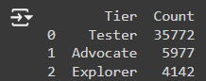

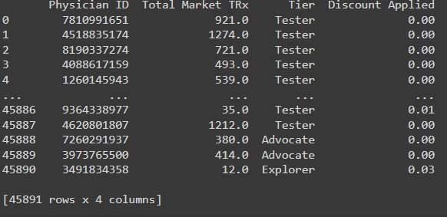

Question 6:

Step 1 : Merge the datasets on the 'Zip' column

Step 2 : Convert columns to numeric in merged dataset

Step 3 : Calculate total sales for both products and markets

Step 4 : Calculate weighted sales for each

Step 5 : Rescale the weighted sales to get the workload index

Output :

Workload Index for each Territory:

Territory Workload_Index

0 AL BIRMINGHAM 961.484188

1 AL HUNTSVILLE 984.999347

2 AZ ARIZONA 1355.438759

3 CA CENTRAL 744.114488

4 CA IRVINE 861.087849

5 CA LONG BEACH 658.333634

6 CA LOS ANGELES NORTH 1081.433032

7 CA RIVERSIDE 1118.508987

8 CA SACRAMENTO 878.418055

9 CA SAN DIEGO 790.236211

10 CA SAN FRANCISCO EAST 917.372312

11 CA SAN JOSE 997.799975

12 CO SOUTH 874.428045

13 CT BRIDGEPORT 626.762206

14 CT HARTFORD 2231.231731

15 FL JACKSONVILLE 1135.097069

16 FL MIAMI 653.600918

17 FL ORLANDO 705.394218

18 FL TALLAHASSEE 864.565066

19 FL TAMPA 967.856563

20 FL WEST PALM BEACH 604.520009

21 GA ATLANTA NORTH 1296.564719

22 GA ATLANTA SOUTH 1128.629818

23 IN INDIANAPOLIS NORTH 2380.929579

24 KY LOUISVILLE 3067.481404

25 LA NEW ORLEANS 1492.105484

26 MD BETHESDA SOUTH 1306.238529

27 MI DETROIT 1741.821915

28 MO KANSAS CITY 1305.144259

29 NC CHARLOTTE 1751.830409

30 NC RALEIGH 1205.771761

31 NC WILMINGTON 978.321973

32 NJ CENTRAL 572.819946

33 NJ HACKENSACK 453.562587

34 NJ NORTHERN 469.179796

35 NJ SOUTHERN 565.401030

36 NV LAS VEGAS 635.033256

37 NY BRONX 395.350347

38 NY BROOKLYN 443.457472

39 NY BUFFALO 1034.145446

40 NY LONG ISLAND EAST 362.600250

41 NY LONG ISLAND WEST 387.564152

42 NY MANHATTAN 534.915722

43 NY QUEENS 298.814801

44 NY WESTCHESTER 917.989876

45 OK OKLAHOMA CITY 1177.899895

46 PA PHILADELPHIA NORTH 720.555675

47 PA PHILADELPHIA SOUTH 747.360045

48 PA PITTSBURGH 2941.838282

49 SC GREENVILLE 1051.337122

50 TN KNOXVILLE 1125.288221

51 TN NASHVILLE 1174.752124

52 TX AUSTIN 952.911050

53 TX DALLAS 1043.928683

54 TX EL PASO 621.200056

55 TX FORT WORTH 747.218605

56 TX HOUSTON NORTH 1136.382253

57 TX IRVING 656.529253

58 VA ALEXANDRIA 1164.441542

Question 7:

lower_bound = 800

upper_bound = 1200

Calculate the number of territories within the balanced range

Calculate the number of territories above and below the balanced range



Question 8:

Step 1 : Sort the dataframe by workload_index in descending order

Plotting:

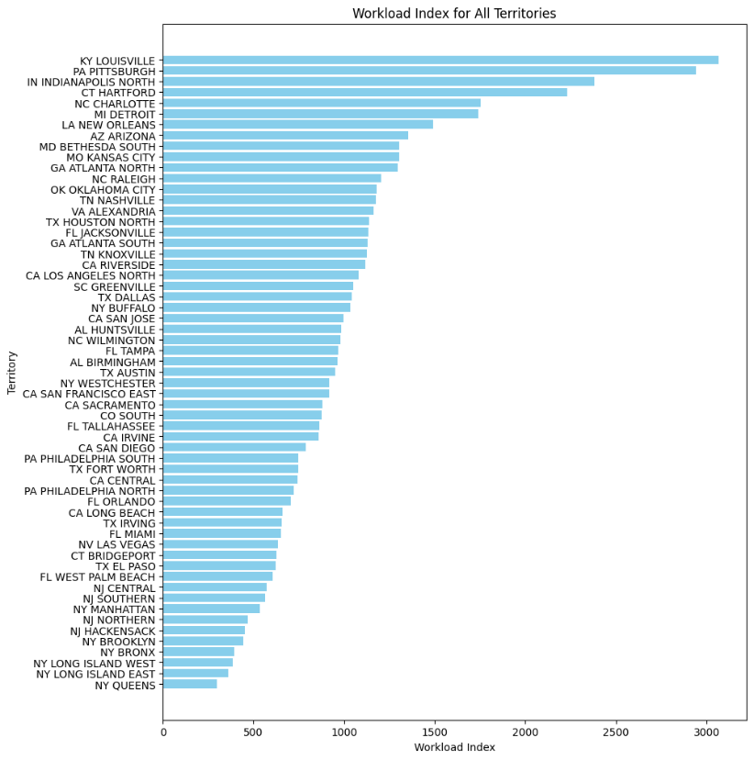

Name : Tanishk Khandelwal

1. <https://colab.research.google.com/drive/18oYUencxNMYVvwqWIfuL29ZKDSuhfN75?usp=sharing>
2. https://docs.google.com/spreadsheets/d/1PAe_L8Td0iRBqbJQ-WkxFdTYLgo9w00uNaEha3E_IMI/edit?gid=0#gid=0

Name :Seelam Aswin Venkata Bhagavan Sai

AD.no : u21cs130

Google Colab:

1. <https://colab.research.google.com/drive/11acB9wIpy816mMTBdOLu2aq5clh3IvNv#scrollTo=Lp6bSdnX7vHP>
2. <https://colab.research.google.com/drive/1coLP9euRnhQUPJhhcUG96vO16feJDsmF#scrollTo=h6na-Etkbzp9>

<https://drive.google.com/drive/folders/1bPN_J1cFZtddFifeVzfgSC4CA-MNTOJH?usp=sharing>

Name : Dikshant Gaur

1. https://drive.google.com/file/d/1MiszCVyrDRoXLWNLrXThGtUy4RBT9CMV/view